Secret Santa   
documentation

## Overview

Secret Santa project is created with intention to mimic a seasonal game where group of people gathers and writes their names on pieces of paper. Names are than put in the hat or box from which a random drawn is made in order to create matching pairs. Pairs are matched such that matched person would know the name only of the person they are matched with. Paired partners would than get gifts for each other which are to be exchanged on pre-decided date. There are several versions of this game, but this project focuses of the basic concept explained above. The project is intended to be used as a fun activity for an office team and number of participants is not limited. Project is developed using Python’s web development framework Django as a backend engine while frontend is designed with Bootrstrap.js

## Objectives

Web application randomly matches registered users into pairs and lists them for gift giving process. If there is an uneven number of participants, the person without pair is listed separately. Upon login, regular participants (Employees) are informed of who their match is while Administrators can see and reset Santa’s list and view, create and delete users from both groups. This project is designed to be played between working colleagues in the office.

Table of Contents

Overview 1

Objectives 1

Features 2

Feature 1: Matching mechanism 2

Feature 2: Authorisation and authentication 2

Feature 3: Santa’s list 2

Feature 4: Users’ list 3

Feature 5: Registration 3

Feature 6: Index 3

Page templates 3

Database diagram 4

Site map 5

Employees’ view 5

Administrator’s view 5

## Features

### Feature 1: Matching mechanism

Matching mechanism is stored as an internal script and is designed to run in such way that one person and the next person from a randomly shuffled list are chosen and paired while list counter is incremented for 2. First person is appended to a new list named *givers* and second person is appended to another list named *receivers.* In case where there is odd number of participants, on *givers* list a null flag is appended while person is stored on *receivers* list and removed from the main list of participants. After the process is completed,lists containing *givers* and *receivers* are passed back to the view where references are matched, and instances of User objects are assigned to Participants fields of givers and receivers respectively. In order to function properly, matching mechanism requires at least 3 people to be registered as Users. This mechanism can only be triggered by users group Administrators, and it ensures that

* No person can be assigned to itself (there’s no x-x pair)
* Once matched, the pair won’t appear more than once on the list.
* Person can be sorted into only one pair. (if x is matched to y, x cannot be matched to z)

### Feature 2: Authorisation and authentication

Authentication is performed by Django’s default mechanisms while authorisation is based on two groups: Employees and Administrators. Administrators are characterised by is_staff flag which is set true for them. Employees is default group for all newly registered users and their presence on the website is limited to log in, index and log out page. Administrators can add and delete users from both groups and view, create and reset Santa’s list accordingly.

### Feature 3: Santa’s list

Santa’s list contains all matched pairs and unmatched person if there is one. It is a list representation of Participants database table where matched people are sorted as givers and receivers, and it is accessible only by Administrators. Once created, Santa’s list will remain the same until an Administrator user requests a new list to be made. Once deleted, old Santa’s list cannot be retrieved.

### Feature 4: Users’ list

Users’ list contains names of all registered users. When displayed, this list shows information such as user’s first name, last name, username, email and group to which person is assigned. Users’ list is reserved only for Administrators who can also delete a user from it. If deleted user was matched, it’s matched partner will be informed that there is no one for them to exchange gifts this season.

### Feature 5: Registration

There are two types of registration. Employee registration is default for every user who chooses to register. Administrators and superuser are allowed to register users in both groups. Registration of users for each group is handled by different function while both render the same template. Users don’t become Participants after registration. Instead they are informed to contact Administrators to reset Santa’s list so they get included as well.

### Feature 6: Index

Index or Home page displays different information to users based on their status. A welcome page with links for login and registration are presented to anonymous users. Newly registered user is presented with a message to contact Administrators in order to be included in the list. Registered and matched users are shown their matched partner while registered but unmatched users are represented with appropriate message informing them about their current status.

## Page templates

**Index** – displays content based on user status.

**All Users** (Administrator’s view) – a list containing all users.

**Santa’s List** (Administrator’s view) – two lists where one contains names of matched pairs and other contains unmatched users in case of odd number of participants.

**Register** – register form for new users. Administrator’s view allows creation of users from both groups while anonymous users would be automatically registered as Employees.

**Participants delete** (Administrator’s view) – first part of a Santa’s list reset process. Administrator is asked if they want to proceed by deleting old list and creating new.

**Participants delete complete** (Administrator’s view) - second part of a Santa’s list reset process. Old list is deleted, and the template is used to trigger a creation of new Santa’s list.

**Log in** – login form after which a user is redirected to index page displaying appropriate information.

## Database diagram

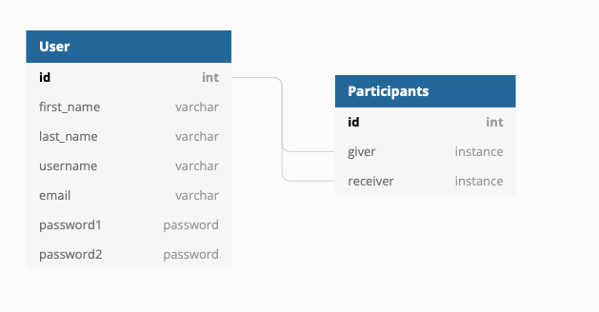

User is considered everyone who is registered in website’s database. Participant is considered every user who participates in matching process. Newly registered users aren’t Participants until a Santa’s list is reset but every Participant contains two instances of User: Giver and Receiver.

## Site map

### Employees’ view

### Administrator’s view

